Memorandum

To: Faculty Senate
Seton Hall University

From: Katia Passerini, Ph.D.
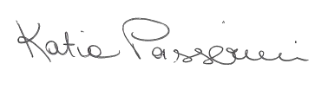
Provost and Executive Vice President

Re: Changes to the Faculty Senate By-laws - EC Composition
2021-FS-07

Date: August 2, 2021

The Office of the Provost is in receipt of Resolution 2021-FS-07 on Changes to Faculty Senate By-laws - EC Composition, approved by the Faculty Senate at its March 26, 2021 meeting.
I approve this Resolution.

