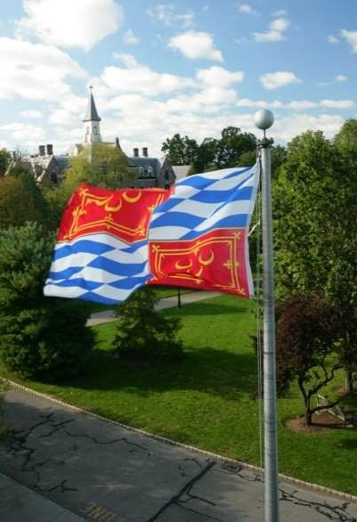
Mar 2021
ISSN 2573-2749
Locus

Seton Hall University’s journal of undergraduate research
Overview The College of Arts and Sciences of Seton Hall University supports undergraduate research in all disciplines and continues its initiative to disseminate students’ scholarly work in journal form. Student editors and contributors, with start-up support from faculty advisors from three principal academic areas, collaborate towards producing an annual publication that presents rigorous undergraduate research.

New call for submissions Scholarly works written by undergraduate students of Seton Hall University are invited; work completed up to two years prior to the Fall 2021 publication date are accepted. We encourage a writing style that, while erudite and conversant with the author’s specific area of research, is also accessible to non-specialists. While not required, works that draw from theories, methods, practices and perspectives of two or more disciplines written in an accessible manner are encouraged. Manuscripts will be peer reviewed by undergraduate student editors of the College of Arts and Sciences who represent the Humanities, Sciences and Mathematics, and Social Sciences. However, contributions from student authors from all Seton Hall colleges and academic units are welcome. Deadline: 21 May 2021

Inquiries Editorial inquiries may be directed by prospective authors to the relevant faculty advisor or student editor (by major or by the proposed publication's discipline).

Editorial Committee for 2021 issue
Nathan Kahl, Faculty advisor-Sciences nathan.kahl@shu.edu
Brooke Mullin, Student editor-Sciences brooke.mullin@student.shu.edu
Donovan Sherman, Faculty advisor-Humanities donovan.sherman@shu.edu
Anne Pino, Student editor-Humanities anne.pino@student.shu.edu
Markela Quin, Student editor-Social Sciences markela.quin@student.shu.edu
Mark Horowitz, Faculty advisor-Social Sciences mark.horowitz@shu.edu
Peter Shoemaker, Dean, College of Arts and Sciences peter.shoemaker@shu.edu

Journal link http://scholarship.shu.edu/locus
Editorial info http://blogs.shu.edu/locus
College of Arts and Sciences, Fahy Hall
400 South Orange Avenue, South Orange NJ 07079
Fast Facts for Volume 4 (2021)
Call for Papers: Winter 2021 |Deadline: 21 May 2021
Contributors: Undergraduate students and recent graduates (within two years) | Content: Interdisciplinary journal-length articles, 5-10 thousand words |Submission: email student editor | Selection: Student peer review Acceptances, revisions: Spring 2021-Summer 2021 | Frequency: Annual Format: Digital, online, open access | Platform: Bepress.com (via University Library) | ISSN:2573-2749 | Copyright: Fair use, Creative commons online
Photo: Seton Hall Image Gallery

