Meet Seton Hall’s Journal of Undergraduate Research:
Locus
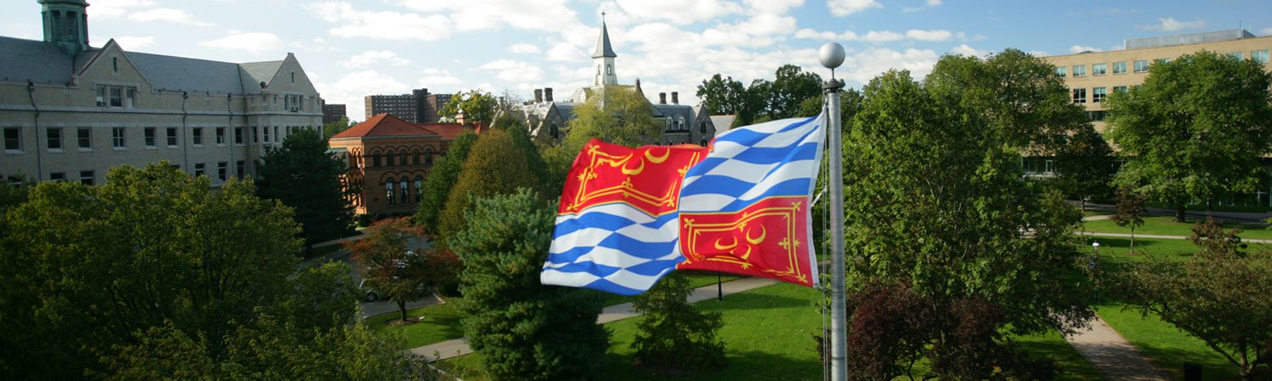
We are currently looking for submissions!

We are now accepting papers written by undergraduate students of Seton Hall University and completed up to two years prior to the Fall 2020 semester

- Deadline: April 16, 2020

For more information reach out to…
Carolina Holguin carolina.holguin@student.shu.edu (Student editor, Humanities)
Liam L McDermott liam.mcdermott@student.shu.edu (Student editor, Social Sciences)

or visit our website… https://scholarship.shu.edu/locus/ | http://blogs.shu.edu/locus/about/

