“Follow the Science”: A Discussion of Public Policy, Scientific and Empirical Research, and American Culture During the COVID-19 Era
Alex Jensen

Introduction
After COVID-19 quickly spread through most countries in early 2020, science became the key to saving lives. Americans, especially business owners, were hit particularly hard economically, socially, and emotionally by the necessary shift to lockdowns. Life for Americans as we knew it changed in an instant. As Americans, we were forced inside our homes with no real plan but to wait and watch. The initial “two weeks to stop the spread” turned into an ongoing journey to fight COVID-19. Some used the isolative pandemic to create new hobbies and lifestyles while others gave up routine and consistency due to the changed state of the world. While some chose to focus the extra time toward an exercise regimen to strengthen their personal health, many individuals remained physically inactive.
In the face of COVID-19, the US government (“Government”) promulgated reactive legislation, because it was the only thing it could do…at least at first. Reactive regulations like masks, social distancing, hand-sanitizer, business closures, and the promise of a vaccine became a staple for a “new normal” and the subject of scrupulous political debate. Americans were generally left feeling hopeless and angry about the state of public health, politics, and their idea of what normal was and ought to be. Reactionary public policy on the state and federal level attempted to limit the spread of the virus. Policies were initially implemented with the goal of eradicating this virus, but eradication quickly became an unlikely scenario. Thus, reactive regulations and policies have shifted away from seeking herd immunity to stop this virus and instead seeks to limit the severe effects on Americans—especially the risk of severe illness or death and crowded hospitals. While different governmental entities have demonstrated good-faith efforts in spreading information and recommendations to Americans, the prevalent recommendations for COVID-19 focus on reactionary measures, which largely ignore personal health and comorbidities—some of which are reversable. Improving health on a personal basis is important if Americans do not want to rely on masks and social distancing as protective measures from severe illness. Nutritional and lifestyle health regulations and recommendations are the next step in “following the science.” This paper looks at public policy and the collective dangers of Americans’ generally inactive lifestyle, a body of scientific literature that emphasizes the importance of physical activity and nutritional needs, and a government which has essentially ignored that scientific literature.
Part I provides an overview of the various policies and recommendations that have circulated since the inception of COVID-19 in the United States. Part I.A looks specifically at the Center for Disease Control’s (“CDC”) website pages and the degree to which they recommend reactive or lifestyle health measures. Part I.B discusses state-level policies, looking specifically at New Jersey’s state-of-emergency and reopening timelines. Part I.C discusses the federal and Presidential plans to combat COVID-19.
Part II discusses scientific studies and how they correlate to the aforementioned groups. Part II.A provides an array of scientific sources that casts a framework for the discussion. Part II.B examines the deviation between the science and the CDC’s COVID-19 website page links and education. Part II.C examines an example of legislative and executive considerations and the degree to which they relate to COVID-19 mitigating steps.
Part III provides recommendations of the best changes to bridge the gap between the current scientific literature and education regarding COVID-19 and personal health. The essay concludes by supporting further education and expansion of health factors for consideration through the CDC’s website and other governmental means in furtherance of combatting potential adverse effects from COVID-19.

I. The Recommendations and Policy of COVID-19
Policies revolving around COVID-19 began in January 2020 when President Donald Trump declared a public health emergency and announced a travel ban of foreign nationals from China. This was the first time in fifty years that the United States had instituted fierce quarantine laws, and it began a long, tedious process of implementing various policies to combat the unknowns of a new virus. States began implementing their own state-of-emergency policies in March 2020, which primarily resulted in stay-at-home orders and closure of most businesses. The CDC became an important provider of COVID-19 information in data around this same time when it began publishing weekly “COVIDView” reports that gave insights into COVID-19 numbers, virology, and the general direction the disease seemed to be heading. States slowly began relaxing restrictions with time. However, this became a point of political debate with individual states delaying or deliberately speeding the reopening of different businesses. Now, the states have a less apparent objective for COVID-19 policies while President Biden has pressed his initiative of vaccinating all Americans. Regardless of the particular state involved, the policies were merely reactions to a quickly spreading virus amidst a population whose unhealthy and older members were at risk of severe illness.
- The CDC
The CDC has been one of the leaders in providing digestible COVID-19 recommendations. The CDC website has pages that form a repository of COVID-19 information which individuals can access easily. Despite the CDC’s continued role in COVID-19 management for the United States, the measures presented generally overlook nutrition- or lifestyle-focused COVID-19 measures in favor of reactive measures.
The CDC’s website has several pages that outline COVID-19 information. On the page entitled “Protect Yourself,” the CDC lists several protective habits: get vaccinated; wear a mask; stay six feet apart from others; avoid crowded spaces and poorly ventilated areas; get tested for COVID-19 to prevent spread to others; wash your hands; cover coughs and sneezes; clean and disinfect; and, monitor your health daily. A linked sub-page on how to protect one’s family includes essentially the same information. These pages provide much of the information that was strongly emphasized at the outset of the pandemic as measures that individuals should take. However, these forms of protection are all inherently reactive measures which may not match the current mental and physical needs of many Americans.
The Science Agenda for COVID-19 provides a clear outlook of priorities for the CDC’s research on the disease. The CDC lays out six priority areas: (I) COVID-19 Disease Detection, Burden, and Impact; (II) Transmission of SARS-CoV-2; (III) Natural History of SARS-CoV-2 Infection; (IV) Protection in Healthcare and Non-healthcare Work Settings; (V) Prevention, Mitigation, and Intervention Strategies; and (VI) Social, Behavioral, and Communication Science. In the fifth section, the CDC states that its objectives for prevention and mitigation strategies include: “evaluate individual—and community—level strategies to limit infection with SARS-CoV-2 … evaluate strategies to limit infection with SARS-CoV-2 in specialized settings or select populations … optimize the acceptability, coverage, safety, and effectiveness of COVID-19 vaccines,” etc. Nowhere in this section does the CDC describe specifics on promoting measures such as diet and exercise to combat the potential for severe illness.
Another page which discusses medical conditions and medical history provides a clear understanding of an individual’s relative risk for COVID-19. The page outlines that populations who are most at risk include older adults, individuals with multiple underlying medical conditions, those with disabilities, and those without access to adequate healthcare. Under the section called “Actions You Can Take,” a subsection points to preventive care, including taking necessary medication, following treatment plans (such as exercise and dietary routines), keeping regular healthcare appointments, and learning about stress and anxiety. Below that, the CDC recommends that those with medical conditions “[h]ave shelf-stable food choices available to accommodate dietary needs based on your medical condition.” However, this presumes that individuals know how to treat their particular medical issue effectively and provides little guidance on what appropriate dietary protocols entail.
The aforementioned policies and initiatives of the CDC are merely reactionary measures for COVID-19. While some COVID-19 efforts may seem like preventive measures on the surface, social distancing and masks are measures used to stymie a highly contagious disease that is already within one’s own community by reducing its spread. This is not enough. The CDC needs to emphasize the consideration of lifestyle and nutritional health measures specifically on COVID-19 pages—not just on other diseases’ pages—because anyone would most likely receive a net-benefit from incorporating lifestyle changes or reminders regardless of relative health status.
- State Policies: New Jersey’s State of Emergency
State COVID-19 policies affected individuals to the greatest degree because they limited individuals’ freedom of travel and controlled the degree to which businesses could operate. Democrat-run states saw generally stronger restrictions while Republican-controlled states had less stringent restrictions. Since the start of New Jersey’s state of emergency, which resulted in the closure the majority of businesses and restriction of social gatherings, restrictions were lifted slowly and systematically. Outdoor restrictions were lifted first in May 2020, followed by the stay-at-home order in June 2020. Popular indoor facilities such as personal care businesses, casinos, and retail stores reopened shortly after. However, it was not until September that gym and fitness centers were allowed to reopen indoor components of their businesses. The public health emergency ended for New Jersey on June 4, 2021, after over a year of various restrictions. Figure 1 shows a timeline of several COVID-19 restrictions easing for New Jersey respective to COVID-19 positive cases for that same time.
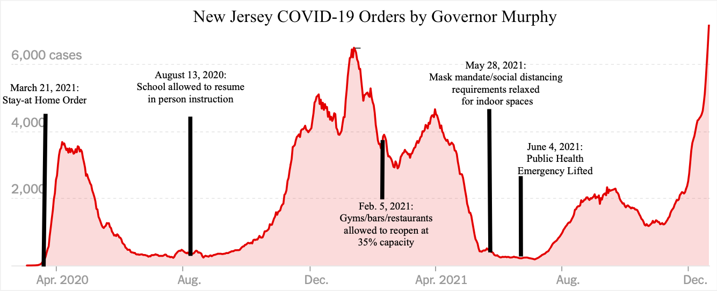
Figure 1. New Jersey COVID-19 Orders by Governor Murphy. This graph depicts the relative increases and decreases of COVID-19 cases within New Jersey compared with the change in COVID-19 orders by Governor Murphy. Despite slow reopenings, COVID-19 cases only had temporary lows which were met by large increases. Omicron became very prevalent to a majority of the cases in December 2021.

All states were essentially open at full capacity as of December 2021. Most state-related business restrictions and mandates were reduced, and stay at home orders were eliminated except in the case of a positive COVID-19 test. However, lingering effects from these closures include forced closures of businesses due to financial difficulties and other businessess which barely survived. While one can debate the efficacy of the timeline for restrictions and when they were lifted, state restrictions seem to be over with—at least for the foreseeable future—despite no true momentum in eliminating or greatly reducing COVID-19 cases.
- Federal Policies and Initiatives
Federal COVID-19 policies affected individuals to a lesser degree but have had profound effects on state actions. President Biden has laid out his plan for combatting COVID-19, which focused on vaccinations, testing, and treatment. However, no prevalent state or federal plan has proposed anything outside of reactionary measures to combat COVID-19 except for vaccines. Instead of being prepared to fight COVID-19 at the outset of an infection, our national policies within the United States have merely prepared us with what we should do only after we or others contract the virus. These recommendations stand despite the uptick in total vaccinations over time and the actual efficacy of the vaccine itself.
Vaccinations seem to be one viable measure of protection against severe illness from COVID-19:
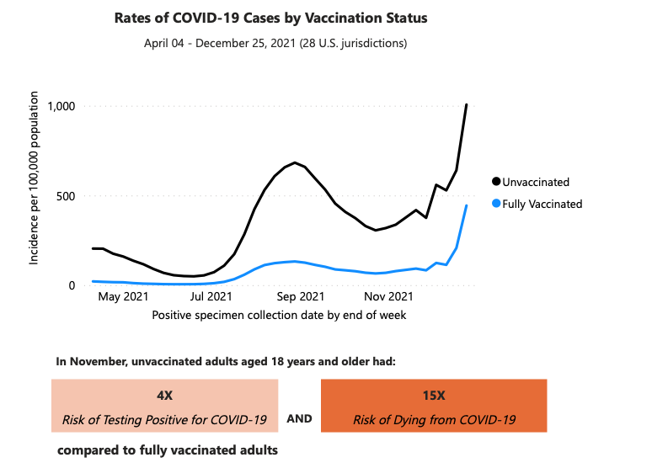
Figure 2. Unvaccinated individuals have had more positive tests for COVID-19 per 100,000 people than fully vaccinated (two-shot) individuals.
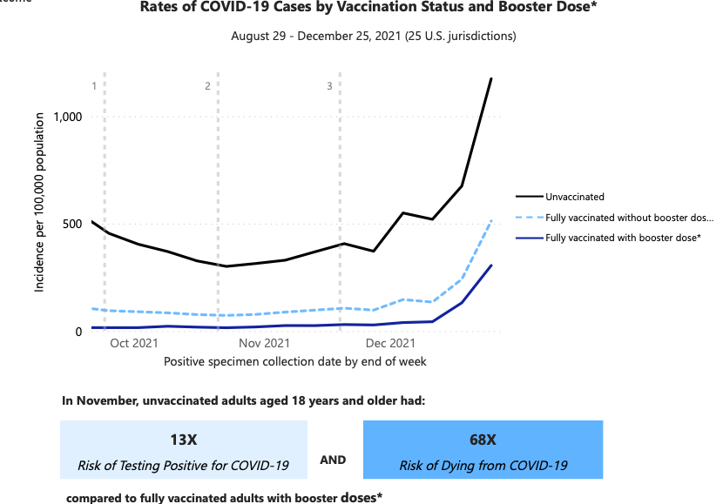
Figure 3. Fully vaccinated individuals with a booster dose have lower risks of testing positive for COVID-19 and lower risks of dying from COVID-19.

Though booster shots may prove to be effective short term, the data still show that spikes are proportionate among the vaccinated and unvaccinated groups, even though the booster group saw the fewest deaths per 100,000 population. In the meantime, both the vaccinated and unvaccinated should seek protection through lifestyle changes. President Biden’s plan to push for vaccines for all Americans does not appeal to all Americans. Other measures might be more appealing as a “band-aid” approach, but President Biden is merely using the information most easily available and explained to him by his advisors. Simply put, the number of “healthy” individuals who are not vaccinated, contract COVID-19 without symptoms, and do not get tested, may go unreported. Thus, the data may be incomplete, and other methods of protection need to be considered.

II. A Discussion of Nutrition and Lifestyle to Combat Adverse COVID-19 Effects
Reactive regulations are certainly not wrong, but they are just half of the solution. Masks are not and should not be a permanent measure for COVID-19 protection. However, an important option—nutritional and lifestyle measures—is largely ignored by Americans due to American culture itself. American culture over the last century has become an increasingly consumerist culture; technological advances and speed of access allowed Americans to fall into a rabbit hole of consumerism without seeing past short-term desires. Unsurprisingly, the culture that demands the better, faster, and smarter of anything and everything was not too keen on staying home and just waiting out an indefinite period of time that seemed to keep extending longer and longer. Then, Americans wanted answers on when restrictions would be lifted, and the government emphasized the importance of the enumerated reactionary measures in stopping the spread of COVID-19. Thus, it is not surprising that only a minority of Americans participate in regular exercise, especially in light of its possible health benefits to combat the harsh symptoms of COVID-19.
Nutritional and lifestyle factors are not prevalent considerations in the United States for many reasons. While a well-balanced diet and exercise are known positives to one’s health, Americans are statistically more likely to eat unhealthy fast food than to exercise. Only 23.2% of Americans meet the recommended physical activity guidelines for aerobic and muscle-strengthening goals as recommended by the CDC. While COVID-19 was a factor in over 750,000 Americans since March 2020, heart disease results in roughly 659,000 deaths in the United States yearly, and cancer results in around 600,000 deaths. Though these other diseases can be passed through genetics, other data points to a confounding variable: lifestyle. This points to a massive problem in our nation’s health, considering the degree to which the aforementioned diseases affect individuals. Additionally, the research on comorbidities and COVID-19 cases should urge Americans to take precautionary measures. Nevertheless, this will require both clear and convincing evidence for Americans, as well as the willingness to make a change.
- The Science
A catalog of scientific studies, which can be found through the linked databases on the CDC website, help demonstrate a partial picture of formidable measures which neither the CDC nor the state or federal governments have focused on. The CDC has distinctly recognized the role of comorbidities in severe COVID-19 cases, which include age, cancer, diabetes, heart conditions, obesity, etc. A 2018 study out of the University of Southern California found that a 16-week combined aerobic and resistance exercise program designed to address metabolic syndrome in ethnically-diverse, overweight, or obese breast cancer survivors also found the subjects had improved quality of life and physical fitness after the 16-week period, and the research points to the inclusion of clinical exercise regiments during breast cancer treatment and care for these remedial effects. Another study out of the Virginia Commonwealth University, which looked at the risks of diabetes and obesity through the mechanisms of diet and exercise, found that behavior modifications can help reverse the effects of an unhealthy diet, increased sedentary behavior, and decreased physical activity and recommended that clinicians more strongly encourage behavior and lifestyle modifications to improve adverse health consequences. While not specific to COVID-19, these studies give examples of the research that looks to exercise and diet as remedial measures in an individual’s personal health in general. Thus, combatting comorbidities should be a strong consideration to limit one’s relative risk of a COVID-19 infection.
Studies have demonstrated an association between muscle-mass and severity of COVID-19 symptoms. A peer-reviewed study out of the University of Padova in Italy concluded that “muscle loss seems to be a predictor of ICU hospitalization in COVID-19 patients and radiologists reporting chest CT at admission should note this finding in their reports.” Another study out of the University of Sao Paolo, Brazil, examined muscle mass and strength of COVID-19 patients upon hospital entry and concluded that, while not abundantly clear, muscular health may benefit patients with moderate-to-severe COVID-19. While these studies do not outright recommend exercise as a means of combating potential future effects of COVID-19, a balanced resistance training program would increase individuals’ muscle mass over time and perhaps decrease those individuals’ health risks.
Within the research, comorbidities have been demonstrated as a strong indication of whether an individual is likely to have a severe or life-threatening bout of COVID-19. One study out of Charles Sturt University in Australia examined habitual physical activity on meta-inflammation and how it provides relative protection against COVID-19. Concluding that “the emerging evidence indicates that the risk of SARS-CoV-2-related complications and mortality appears to be higher in individuals with comorbidities, and/or evidence of systemic inflammation,” this study supports the contention that exercising can and should be utilized as a strategy for improving the immune system and, as a result, preparing one’s body to fight the COVID-19 virus.
Scientific studies should be taken with a grain of salt; they rarely develop a clear picture of causation and do not often come to a macro-level conclusion. Despite that, the scientific evidence as outlined here has developed a clear relationship between an individual’s pattern of physical activity with their immune system and symptomatic response to COVID-19. It makes intuitive sense: a healthier body is going to fight a disease better than a less-healthy body. While understanding that living a healthier lifestyle could have positive impacts relating to a COVID-19 infection, Americans have barely been able to follow easier, reactionary policies; therefore, it is unsurprising that these types of measures or recommendations are not strongly considered.
- The CDC’s Nutritional and Lifestyle Recommendations
Empirically, age is the highest risk factor for severe COVID-19 illness. However, rather than remaining defined by categories which label someone “at risk,” and while understanding that compounding comorbidities clearly leads to a greater risk of severe illness, the CDC could make clearer the importance that an exercise and dietary regimen can be to giving the individual the best chance to overcome COVID-19. However, the CDC omits these considerations.
Currently, the CDC does have recommendations for daily exercise, but it is separate from COVID-19 recommendations. Very clearly on the top of this designated page, the CDC emphasizes that “some activity is better than none.” This page gives some guidance—albeit, minimal guidance—on how much exercise is recommended as a minimum and what counts toward that amount. Further, the page includes the notion that when adults participate in physical activity, they “gain some health benefits.” However, the CDC does not describe on this page what those health benefits are. Had the CDC tied these to a reduced risk of diseases, reversing impact of certain conditions, or reduced risk of an adverse reaction to COVID-19, the health benefits would be utterly apparent.
The CDC also has a page which explains the benefits of physical activity, but it is not linked to the aforementioned exercise recommendations for adults. However, this page does not include COVID-19 protection on its list of benefits, as it should. The page discusses how physical activity can reduce one’s risk of cardiovascular disease, metabolic syndrome and diabetes, and some cancers. Additionally, physical activity also gives immediate benefits of reducing anxiety and depression and bettering sleep. All of these things, as discussed in the scientific literature, are factors in predicting the likelihood of adverse COVID-19 symptoms and likelihood of death as comorbidities. The CDC misses a two-for-one opportunity for American health by not tying the link on its website between reducing the presence of comorbidity risk specifically to their relationship with COVID-19.
The CDC’s nutrition page offers more of a clear objective. On this page, one section’s header clearly reads “Poor Nutrition Is Making Our Nation Sick.” Below that, the CDC includes a short blurb stating that poor nutrition can contribute to many diseases, including heart disease, obesity, and cancer. The scientific literature clearly offers that these diseases are comorbidities that many Americans are at risk of and thus put them at risk for severe illness or death from a COVID-19 infection. Although the CDC clearly draws the importance of nutrition in disease, and despite the apparent importance in the scientific literature, the CDC fails to explicitly draw the importance of nutrition regarding protection against COVID-19. While Americans may be able to see these relationships subliminally, Americans would be better served if this relationship was explicitly noted on these types of pages. Even if most Americans do not visit these pages, the statements will demonstrate the CDC’s commitment to scientific information that Americans can apply in a clear, actionable manner.
- Legislative and Executive Recognition of Nutritional Measures
A next step in the United States’ fight against severe illness and death related to COVID-19 should be to implement a stronger emphasis on nutritional guidance to reduce the comorbidity risk. Many of the negative consequences of a poor diet and little exercise have been shown to be reversible, or at least mitigative, in the scientific literature. Thus, individuals might not need to be at risk if they take proper measures that government entities can help with.
Tucked away in a 2020 infrastructure bill, Congress has reaffirmed the importance of furthering the research of dietary guidelines:
Not later than 1 year after the date of enactment of this Act, the National Academy of Sciences, Engineering, and Medicine shall complete a review and provide a report to the Secretary of Agriculture, the Secretary of Health and Human Services, and the Congress, on the most recent edition of the dietary guidelines for Americans that includes the following:
(1) A comparative analysis of the scientific methodologies, review protocols, and evaluation processes used to develop the most recently issued guidelines as compared to recommendations included in the National Academy of Sciences, Engineering, and Medicine September 2017 report entitled "Redesigning the Process for Establishing the Dietary Guidelines for Americans".
(2) A comparative analysis of the scientific studies used to develop such guidelines to determine the dietary needs of Americans with diet-related metabolic diseases as compared to the most current and rigorous scientific studies on diet and diet-related metabolic diseases available.
(3) An analysis of how full implementation of the recommendations described in paragraph (1) would have affected the most recently issued guidelines.

Congress, like the CDC, does not emphasize here the importance of diet in relation to the pandemic. While it is not necessarily the job of the legislature to emphasize certain scientific provisions in their bills, it would only make sense for this legislature to focus efforts on nutritional research in relation to COVID-19 as well, considering the discussion on the CDC’s diet information. Improved nutritional research will serve to stymie some of the risks of comorbidities to COVID-19 and other unfavorable diseases.
While other world leaders, such as Prime Minister Boris Johnson of the United Kingdom, have addressed obesity as a severe risk for adverse COVID-19 symptoms, Presidents Trump and Biden have not. Prime Minister Johnson, in order to combat unhealthy habits in the United Kingdom, took controversial actions such as banning junk food in television commercials before nine o’clock in the evening. Biden has expressed a similar sentiment by expanding the Supplemental Nutrition Assistance Program (SNAP). Critics have argued that it provides more access to unhealthy food choices, and supporters claim this will help improve diets. Regardless, SNAP would be a viable option to combat unhealthy eating habits if it was specifically tailored to nutritional education and provided eligible Americans with healthier and more nutritious food options, rather than merely providing access to funds to purchase food.

III. Conclusion: What Needs to Change?
The CDC can and should promote nutritional and lifestyle measures. The CDC should update its website to include factors about personal health mentioned in this paper. The CDC should bolster its COVID-19 pages by strongly recommending nutritional and lifestyle measures that individuals can take to better their own health which, in turn, betters their chances of fighting the virus. Health information needs to be accessible to the public in a manner that is digestible and easy to access. Providing valid, science-backed information for individuals has more benefits than detriments. If individuals willfully ignore their personal health despite conscious efforts by the CDC to educate individuals, then that no longer falls on the CDC. Without providing educational resources, however, the CDC fails to satisfy one of its nominal goals: disease control.
Similarly, President Biden should use his influence to back this science, amend his COVID-19 plan, and push to adjust SNAP as outlined above. Vaccinations are an understandable staple in President Biden’s plan. However, a vaccine combined with the nutritional and lifestyle measures recommended by this paper would provide a double-edged sword against COVID-19 and other lifestyle-related diseases. President Biden needs to act in accordance with the above changes by the CDC for Americans not only to get vaccinated but also to take care of themselves within the recommended exercise and nutritional resources available. President Biden’s initiative with COVID-19 may prove important in his possible bid for reelection, so taking the initiative to present as much of an actionable plan as possible seems to be a necessary step for his administration.
Private companies can be—and, realistically, have been—leaders in this initiative in positive health habits. Peloton, for example, became very popular at the outset of the pandemic for at-home exercise, but sales for Peloton began declining after lockdown restrictions eased. However, private companies only have so much influence because they do not have the same power as government and are limited to the ebbs and flows of present demand. Governmental agencies have the only viable influence on many Americans through their information networks and mandates. Private companies should not waiver in promoting positive health outlooks for consumers, but governmental entities are truly obligated to supplant the current attitude about health with a reality that follows the science. Congress, President Biden, and the CDC need to work together to assess the reality of the science and empirical data. They need to develop plans and recommendations that better educate Americans about exercise and nutritional measures that largely mitigate negative effects of COVID-19 infections.
It is ultimately the job of the individual to be responsible for his or her own health by applying these practices and encouraging others to do the same. The current way of life for Americans has divided the country; we must proceed in unity. Public policy is shaped around the desires of a country’s citizens, and we need a staunch change in mindset if we ever want to see a decline in health issues that seem to compound year after year. COVID-19 is our wake-up call. We cannot be dogmatic with what we want; we must be willing to incorporate into our lives what we need. We need the best protections afforded to us, even if we must work for them.

COVID Data Tracker, Center for Disease Control (last visited Dec. 20, 2021), https://covid.cdc.gov/covid-data-tracker/#trends_dailydeaths%7Cnew_death%7Cselect.
Kate Stringer, The pandemic changed our daily routines. Here’s how that’s impacting mental health, productivity and the environment, University of Washington Graduate School (Nov. 18, 2020), https://depts.washington.edu/urbanuw/news/the-pandemic-changed-our-daily-routines-heres-how-thats-impacting-mental-health-productivity-and-the-environment/.
How the Pandemic is Changing Our Exercise Habits, The New York Times (Oct. 7, 2020), https://www.nytimes.com/2020/10/07/well/move/pandemic-exercise-habits-study.html.
Rebecca L. Haffajee, et al, Thinking Globally, Acting Locally – The U.S. Response to Covid-19, The New England Journal of Medicine (May 28, 2020), https://www.nejm.org/dofi/full/10.1056/NEJMp2006740.
In this paper, “reactionary” or “reactive” policy describes policy changes in response to an issue being presented. Examples of reactionary policies include masks, quarantining, and social distancing.
Nirmita Panchal, et al, The Implications of COVID-19 for Mental Health and Substance Abuse, KFF (Feb. 10, 2021), https://www.kff.org/coronavirus-covid-19/issue-brief/the-implications-of-covid-19-for-mental-health-and-substance-use/.
Michael Le Page, Why eradication is unlikely, US National Library of Medicine National Institutes of Health (Jan. 23, 2021), https://www.ncbi.nlm.nih.gov/pmc/articles/PMC7825892/.
Apoorva Mandavilli, Reaching ‘Herd Immunitiy’ Is Unlikely in the U.S., Experts Now Believe, The New York Times (May 3, 2021), https://www.nytimes.com/2021/05/03/health/covid-herd-immunity-vaccine.html.
“Nutritional and lifestyle” health regulations and recommendations include any body of literature or stance by the government or its agencies in furtherance of Americans participating in dietary, exercise, and habitual practices which promote the greatest health benefits.
Allison Aubrey, Trump Declares Coronavirus A Public Health Emergency And Restricts Travel From China, NPR (Jan. 31, 2020, 4:42 PM), https://www.npr.org/sections/health-shots/2020/01/31/801686524/trump-declares-coronavirus-a-public-health-emergency-and-restricts-travel-from-c.
Id.
See, e.g., NJ Exec. Order 103 (Mar. 9, 2020), https://nj.gov/infobank/eo/056murphy/pdf/EO-103.pdf.
See, e.g., COVIDView Summary ending on March 28, 2020, Center for Disease Control (Mar. 28, 2020), https://www.cdc.gov/coronavirus/2019-ncov/covid-data/covidview/past-reports/04032020.html.
Dena Bunis, et al, List of Coronavirus-Related Restrictions in Every State, AARP (Dec. 20, 2021, 3:56 PM), https://www.aarp.org/politics-society/government-elections/info-2020/coronavirus-state-restrictions.htm.
Theresa Waldrop, et al, Florida and Georgia face backlash over COVID-19 case total accuracy, WINK (May 20, 2020, 11:09 AM), https://www.winknews.com/2020/05/20/florida-and-georgia-face-backlash-over-covid-19-case-total-accuracy/.
Fact Sheet: Biden Administration Announces Details of Two Major Vaccination Policies, The White House (Nov. 4, 2021), https://www.whitehouse.gov/briefing-room/statements-releases/2021/11/04/fact-sheet-biden-administration-announces-details-of-two-major-vaccination-policies/.
See, CDC Museum COVID-19 Timeline, Center for Disease Control (last visited Dec. 20, 2021), https://www.cdc.gov/museum/timeline/covid19.html.
Coronavirus Disease 2019 (COVID-19), Center for Disease Control (last visited Dec. 20, 2021), https://www.cdc.gov/coronavirus/2019-nCoV/index.html.
See, e.g., Rates of COVID-19 Cases and Deaths by Vaccination Status, Center for Disease Control (Dec. 22, 2021, 1:15 PM), https://covid.cdc.gov/covid-data-tracker/#rates-by-vaccine-status (illustrating that vaccines have been demonstrated as a preventative measure to severe COVID-19 illness and that much of the data point a toward lower risk of severe illness in COVID-19 patients who were previously vaccinated).
Coronavirus Disease 2019, supra Note 18.
How to Protect Yourself & Others, Center for Disease Control (last visited Dec. 20, 2021), https://www.cdc.gov/coronavirus/2019-ncov/prevent-getting-sick/prevention.html.
Families with Vaccinated and Unvaccinated Members, Center for Disease Control (last visited Dec. 20, 2021), https://www.cdc.gov/coronavirus/2019-ncov/your-health/about-covid-19/caring-for-children/families.html.
CDC Public Health Science Agenda for COVID-19, Center for Disease Control (last visited Dec. 20, 2021), https://www.cdc.gov/coronavirus/2019-ncov/science/science-agenda-covid19.html.
Id.
Id.
People with Certain Medical Conditions, Center for Disease Control (last visited Dec. 20, 2021), https://www.cdc.gov/coronavirus/2019-ncov/need-extra-precautions/people-with-medical-conditions.html.
Id.
Id.
Id.
Rose Baker, Reactive Social distancing in a SIR model of epidemics such as COVID-19, University of Salford School of Business (Mar. 18, 2020), https://arxiv.org/pdf/2003.08285.pdf (discussing social distancing as a reactive measure).
Alison Durke, Covid Spread Was 8% Lower In Democrat-Led States Than GOP Because Of Stricter Restrictions, Study Finds, Forbes (Oct. 11, 2021, 2:07 PM), https://www.forbes.com/sites/alisondurkee/2021/10/11/covid-spread-was-8-lower-in-democrat-led-states-than-gop-because-of-stricter-restrictions-study-finds/?sh=28dfa6c4352c.
When is New Jersey lifting restrictions?, New Jersey COVID-19 Information Hub (last visited Dec. 20, 2021), https://covid19.nj.gov/faqs/nj-information/reopening-guidance-and-restrictions/when-is-new-jersey-lifting-restrictions.
Id.
Id.
Id.
Id.; Graph from Tracking Coronavirus in New Jersey: Latest Map and Case Count, The New York Times (last visited Dec. 20, 2021, 4:22 PM), https://www.nytimes.com/interactive/2021/us/new-jersey-covid-cases.html.
Dena Bunis, supra Note 14.
Alexander W. Bartik, et al, The impact of COVID-19 on small business outcomes and expectations, Proceedings of the National Academy of Sciences (July 28, 2020), https://www.pnas.org/content/117/30/17656.
Dena Bunis, supra Note 14. Note: the article writes relative to the end-of-year for 2020 with respect to then-current COVID-19 cases.
President Biden’s COVID-19 Plan, The White House (Dec. 20, 2021, 4:23 PM), https://www.whitehouse.gov/covidplan/. See also, Elena Moore, Trump’s and Biden’s Plans On The Coronavirus Pandemic, NPR (Oct. 2016 2020, 8:01 AM), https://www.npr.org/2020/10/16/919139204/trumps-and-biden-s-plans-on-the-coronavirus-pandemic#trumpplan.
Rates of COVID-19 Cases and Deaths by Vaccination Status, Center for Disease Control (last visited Jan. 22, 2022), https://covid.cdc.gov/covid-data-tracker/#rates-by-vaccine-status.
Id.
Vinicius Albani, et al, COVID-19 underreporting and its impact on vaccination strategies, BMC Infectious Diseases (Oct. 28, 2021), https://bmcinfectdis.biomedcentral.com/articles/10.1186/s12879-021-06780-7.
Lisa M. Brosseau, et al, COMMENTARY: What can masks do? Part 1: The Science behind COVID-19 protection, University of Minnesota Center for Infectious Disease Research and Policy (Oct. 14, 2021), https://www.cidrap.umn.edu/news-perspective/2021/10/commentary-what-can-masks-do-part-1-science-behind-covid-19-protection.
80% of Americans Don’t Get Enough Exercise – and Here’s How Much You’ll Actually Need, Cleveland Clinic healthessentials (Nov. 20, 2018), https://health.clevelandclinic.org/80-of-americans-dont-get-enough-exercise-and-heres-how-much-you-actually-need/.
Anup Shah, Consumption and Consumerism, Global Issues (Jan. 5, 2014), https://www.globalissues.org/issue/235/consumption-and-consumerism (concluding that political causes of poverty are largely a result of consumerism and its associated political issues).
Matthew T. Tull, et al, Psychological Outcomes Associated with Stay-at-Home Orders and the Perceived Impact of COVID-19 on Daily Life, US National Library of Medicine National Institutes of Health (May 12, 2020), https://www.ncbi.nlm.nih.gov/pmc/articles/PMC7252159/.
Justin Sink, et al, Biden Asks Americans to ‘Mask Up’ for 100 Days, Criticizing GOP, Bloomberg (Jan. 15, 2021, 4:22 PM), https://www.bloomberg.com/news/articles/2021-01-15/biden-asks-americans-to-mask-up-for-100-days-criticizing-gop.
Leslie Barrie, Many American Adults Eat Fast Food Daily – Here’s Why That’s a Problem, Everyday Health (Oct. 24, 2018), https://www.everydayhealth.com/diet-nutrition/diet/percent-american-adults-eat-fast-food-daily-cdc-report/; Simone A. French, et al, Nutrition quality of food purchases varies by household income: the SHoPPer study, BMC Public Health (Feb. 26, 2019), https://bmcpublichealth.biomedcentral.com/articles/10.1186/s12889-019-6546-2.
Exercise or Physical Activity, Center for Disease Control (last visited Dec. 20, 2021), https://www.cdc.gov/nchs/fastats/exercise.htm
Quickstats: Cancer and Heart Disease Death Rates, Among Men and Women Aged 45-64 Years – United States 1999-2018, Center for Disease Control (last visited Dec. 20, 2021), https://www.cdc.gov/mmwr/volumes/69/wr/mm6921a4.htm.
Know Your Risk for Heart Disease, Center for Disease Control (last visited Dec. 20, 2021), https://www.cdc.gov/heartdisease/risk_factors.htm.
COVID-19 Databases and Journals, Center for Disease Control (Dec. 20, 2021, 4:50 PM), https://www.cdc.gov/library/researchguides/2019novelcoronavirus/databasesjournals.html.
People with Certain Medical Conditions, supra note 26.
Christina M Dieli-Conwright, et al, Aerobic and resistance exercise improves physical fitness, bone health, and quality of life in overweight and obese breast cancer survivors: a randomized controlled trial, National Library of Medicine (Oct. 19, 2018), https://pubmed.ncbi.nlm.nih.gov/30340503/.
Salvatore Carbone, Obesity, risk of diabetes and role of physical activity, exercise training and cardiorespiratory fitness, Progress in Cardiovascular Diseases (July-August 2019), https://www.sciencedirect.com/science/article/pii/S0033062019301070?via%3Dihub.
Chiara Giraudo, et al, Reduced muscle mass as predictor of intensive care unit hospitalization in COVID-19 patients, Plos One (June 17, 2021), https://journals.plos.org/plosone/article?id=10.1371/journal.pone.0253433.
Saulo Gil, et al, Muscle strength and muscle mass as predictors of hospital length of stay in patients with moderate to severe COVID-19: a prospective observational study, Journal of Cachexia, Sarcopenia, and Muscle (Sept. 14, 2021), https://onlinelibrary.wiley.com/doi/10.1002/jcsm.12789.
^{Yea} Wern Hann Ng, et al, Comorbidities in SARS-Cov-2 Patients: a Systematic Review and Meta-Analysis, mBio (Feb. 9, 2021), https://journals.asm.org/doi/10.1128/mBio.03647-20.
Frank E. Marino, et al., Metabolic and inflammatory health in SARS-CoV-2 and the potential role for habitual exercise in reducing disease severity, Nature Public Health Emergency Collection (Nov. 1, 2021), https://www.ncbi.nlm.nih.gov/pmc/articles/PMC8558095/.
Id.
COVID-19 Risks and Vaccine Information for Older Adults, Center for Disease Control (last visited Dec. 20, 2021), https://www.cdc.gov/aging/covid19/covid19-older-adults.html
How much physical activity do adults need?, Center for Disease Control (last visited Dec. 20, 2021), https://www.cdc.gov/physicalactivity/basics/adults/index.htm.
Id.
Id.
Id.
Benefits of Physical Activity, Center for Disease Control (last visited Dec. 20, 2021), https://www.cdc.gov/physicalactivity/basics/pa-health/index.htm
Id.
Id.
Why It Matters, Center for Disease Control (last visited Dec. 20, 2021, 5:08 PM), https://www.cdc.gov/nutrition/about-nutrition/why-it-matters.html
Id.
Id.
See, e.g., M.H. Vickers, et al, Strategies for Reversing the Effects of Metabolic Disorders Induced as a Consequence of Developmental Programming, Frontiers in Psychology (Jul. 2, 2012), https://www.ncbi.nlm.nih.gov/pmc/articles/PMC3387724/.
116 P.L. 260, 2020 Enacted H.R. 133, 116 Enacted H.R. 133, 134 Stat. 1182
Helena Bottemiller Evich, Diet-related diseases pose a major risk for Covid-19. But the U.S. overlooks them., Politico (Oct. 31, 2021, 7:00 AM), https://www.politico.com/news/2021/10/31/covid-deaths-diet-diseases-nutrition-america-517076.
Id.
Id.
Id.
Matt Ott, Peloton hits the wall after sprinting through pandemic, Associated Press (Nov. 5, 2021), https://apnews.com/article/coronavirus-pandemic-business-lifestyle-health-3e8ca0b9be0c02650ea60c32f0b688ad.

