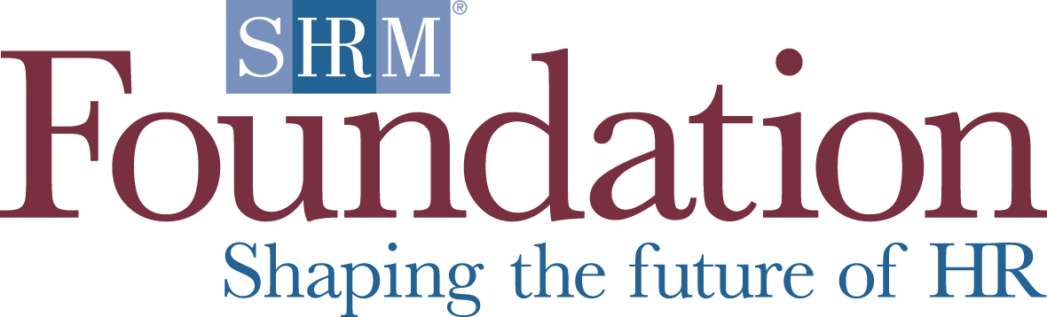

Call for Proposals
November 5, 2012-January 31, 2013

The Science and Practice of Social Media Use in Organizations
The SHRM Foundation is seeking proposals for research pertaining to social media in HR functions. This topic is a major priority on the Foundation’s research agenda.

Social media, such as LinkedIn, Facebook, YouTube, and Twitter, have changed the way people connect and share information and have the potential to revolutionize a wide variety of organizational functions, including recruitment, staffing, training and development, and knowledge sharing. However, this revolution offers both potential benefits and risks for organizations, and it is unclear if the espoused benefits exceed the risks. The current academic literature offers little guidance for organizations embarking on the journey to integrate social media within their processes and systems.

To help shed light on this important topic, the Society for Human Resource Management Foundation is seeking to fund research directed toward understanding social media use in organizations. Research is needed to understand how social media can best be integrated into various HR functions (e.g., recruitment, staffing, training and development, knowledge sharing). Current themes identified by the SHRM Foundation are described below.

Research proposals on the following topics and others related to social media use in HR functions are welcomed:

For which activities is social media effective? Which areas of HR will benefit the most from the integration of social media initiatives? What aspects of the HR function make it more or less amenable to effective social media use and why? Further, how can organizations integrate social media into HR functions in the most effective, ethical, and legally defensible manner?

What are some best practices for implementing social media? Ignoring or underinvesting in social media is a primary risk that could put a company at a competitive disadvantage. While some companies are taking a “wait and see” approach, others are plunging into social media headfirst. What are the leading practices among organizations in deploying social media internally as well as externally in organizational learning, the creation of informal employee networks and using social media to bring together a global workforce?

What kinds of social media policies should be used and who should be responsible for those policies? For instance, HR may be charged with the responsibility of monitoring social media recruitment efforts whereas IT may be responsible for monitoring employee use of personal social media web pages. Further, social media is constantly evolving. Organizations should ensure they adapt to the changing social media environment. This includes revising policies as necessary and instituting new interventions to best use social media to reach objectives.

What legal and other risks does social media use pose? The explosion in social media use by employees has increased the types and level of exposure for organizations. Employees now have a virtual megaphone to the world, which allows them to convey information almost instantaneously. Organizations are trying to determine the legal risks of using social media and how they might mitigate those risks. For example, what risks does social media pose related to copyright abuse, NLRB violations, anti-trust challenges, document retention, privacy breaches, loss of confidential information, and general reputational risk? Although the same compliance, legal, professional, and ethical principles that apply to other HR practices also apply to social media, the nature and uses of social media are quite different and still evolving. Further, with social media every employee in the organization has the capacity to do far greater damage much faster and wider than ever before, requiring a new degree of diligence. What types of interventions are most effective at mitigating the potential risks associated with social media use, and why?

How do organizations assess social media effectiveness? How does an organization demonstrate an investment in social media as a return on investment? What are the relevant performance metrics? Organizations are currently struggling with these issues. In fact, in a SHRM survey, 79% of organizations examined indicate that they do not use analytics or reporting tools to measure the return on investment for their organization’s social media efforts (SHRM, 2011).

- Proposal Format

These emerging issues, and others, need to be explored across industries and in large and small organizations alike. If you feel you possess the capabilities and expertise to investigate any of these topics, please submit a proposal that adheres to the required proposal format.

The length of the proposal should not exceed 15 double-spaced pages in total (1” margins, 12 pt Times New Roman font or equivalent), excluding the cover page, references, appendices and the grant submission checklist. Proposals, checklist and all appendices should be submitted as a single Word file. A second copy of the proposal must also be submitted that excludes identifying information, to aid in the blind review process.

For complete instructions for how to submit a SHRM Foundation grant proposal and for the grant checklist, please visit our website at: http://www.shrm.org/about/foundation/research/Pages/default.aspx

- Evaluation Criteria

The SHRM Foundation funds high impact HR research, aimed at an academic audience while also having direct actionable implications for HR practice. The grant must be for original rigorous empirical academic research that advances the HR profession. While aimed at an academic audience, funded research should also have clear applicability for HR practice and help contribute to evidence-based HR. As such, projects submitted for funding should have a high likelihood of both adding value to the HR academic literature (i.e., be suitable for leading academic journals) and yielding practical implications for HR managers (i.e., applied outlets should be interested in the research results). It is crucial that there is continuity between the research questions proposed and the methods used. The research should also be able to reasonably generalize across people and settings. Investigators should include a statement in the proposal regarding the individuals, groups, industry sectors or countries for which their findings are expected to generalize, given the sample and study design. The SHRM Foundation is open to funding research using any type of research methodology as long as the proposed methodology is sound and appropriate for the proposed research question(s). Those research questions typically (but not solely) take the form of theoretically derived hypotheses.

Letter of Inquiry:
Before submitting a proposal to the SHRM Foundation, we strongly encourage the researcher to submit a letter of inquiry describing the proposed research study. The intent of this process is to help facilitate the match between the proposal and the SHRM Foundation's requirements. The letter of inquiry may be submitted via the following link: http://fs16.formsite.com/SHRMFdn/form6/index.html

Proposal Submission and Deadlines:
The SHRM Foundation will award a grant (or grants) for this project up to $100,000. Proposals will be accepted through January 31, 2013 and may be submitted online at http://www.shrm.org/about/foundation/research/. Final funding decisions will be announced by April 25, 2013.
For more information, contact:
Lynn McFarland
SHRM Foundation Research Coordinator
lynnmcfarland@bellsouth.net

