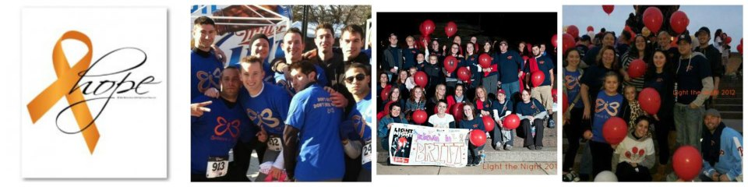
“Don’t Give Up…Don’t Ever Give Up”

Brittany was the oldest of 4 children. Her siblings include Sean, 22 Adriana, 11 and Isabella, 9. She was raised in the Olney section of Philadelphia and attended Cardinal Dougherty High School. Prior to her diagnosis Brittany was enrolled fulltime at Seton Hall University working towards her Masters of Science Degree in Speech Language Pathology and working full time as a private nanny for several families. Brittany received a Bachelor of Science in Special Elementary Education and a Bachelor of Arts Degree in Early Childhood Education in May, 2009. She focused her clinical studies on children with Autism as well as children who are emotionally disturbed. Brittany worked tirelessly to complete her Master’s Degree through the entire trauma of treatment. She completed all of her course work and multiple clinical internships during the various phases of her illness and graduated from Seton Hall University in May, 2013 receiving the top award for her program in all around student, clinical, and research student. We are very proud of her strength and endurance through it all!
Brittany was diagnosed on March 6, 2010 with AML M4 EO Leukemia. She began induction chemotherapy on March 9, 2010 and stayed in the Oncology Unit for 4 weeks. She received outpatient consolidation chemotherapy treatment at The Hospital of the University of Pennsylvania from April 2010 until August 2010. Her remission was confirmed and she was in the process of moving on with her life.
On January 7, 2011, Brittany was informed that she had relapsed. Due to the fact that the Leukemia had returned so quickly she was admitted on January 19, 2011 which was also her 23rd Birthday to endure another round of Chemotherapy treatment which was stronger and more intense than the first time. This was also the day that she was supposed to start back up with her graduate program for Speech-Language Pathology. Instead of attending classes, she was faced with battling another round of infections and side effects that were so painful they rendered her basically helpless and unable to swallow for weeks.
At this point Brittany was being prepared for a Bone Marrow Transplant. She had an anonymous donor which we as her family refer to as our “anonymous angel” and received the transplant on April 1, 2011. Brittany had to face the fact that there would not be enough time to freeze her eggs due to the aggressive nature of her treatment and the high likelihood that she would not ever be able to have children. The recovery from a Bone Marrow Transplant required Brittany to virtually be quarantined because the new bone marrow introduced into her body killed her existing cells and rendered her body devoid of an immune system. This fact alone leaves a transplant patient at the mercy of any number of germs that most people can fight off naturally. Brittany pushed through and even though she suffered several infections over a 4 month period, she was again told that she was in remission.
In February of 2012 Brittany began having trouble walking. She was persistent with her doctors and had many tests done to see what was causing this increasing pain. She was in such agony that she was unable to sleep or sit or walk. She could find no relief. On April 15, 2012 the results of an MRI confirmed that a mass had been found on L3 in her spine. A biopsy revealed that leukemic Cells had built up at the base of Brittany’s spine resulting in a Leukemic Tumor which is wrapped around major nerves in her spine. She began receiving radiation treatment on April 19. During the subsequent visits to the doctor Brittany was informed that she has Leukemic Cells still active in her spinal fluid. She was also receiving weekly Chemotherapy treatment injected directly into the Spine.
On May 13, 2012 Brittany had to make a decision, allow the Leukemic cells to invade her body which would be fatal or receive a donor leukocyte infusion (DLI). In this procedure, the patient receives a boost of immune cells from the original donor's blood. This procedure has a high probability to cause Graft versus Host Disease (GVHD). This treatment has however proved fatal in 5-10% of patients of cases where patients developed complications or infections stemming from the GVHD following DLI. Either decision she made could ultimately be fatal. She chose to have the donor leukocyte infusion and take the chance to live.
On November 28, 2012 Brittany received some more bad news. The leukemia was still in her spinal fluid and had continued to form masses in and around her spinal column. She began preparing to receive Proton Therapy, which is an experimental radiation treatment. On that same day, Brittany and her family suffered the sudden and tragic loss of Brittany’s cousin, Joey Merlino at the age of 28. Brittany and Joey were raised like siblings and suffering this loss while fighting to live were by far the most difficult 8 months of Brittany’s life. But through it all she continued to work toward her degree.
On May 18, 2013 we were honored to attend Seton Hall University to witness Brittany accepting her Master’s degree that she worked so hard for. It was one of the proudest moments for us. To see someone who faced so many obstacles succeed in her ambition was truly inspiring.
With routine follow up testing a Pet Scan revealed in early April, 2013 that there were more tumors in Brittany’s spinal area. After several failed attempts to find a donor willing to give, another anonymous angel took on the challenges. On July 9, 2013 she began the inpatient preparation to undergo intense chemotherapy to prepare her for her second bone marrow transplant.
On July 18, 2013 Brittany received her 2nd Bone Marrow Transplant. All was well for about a week. On July 28, 2013 after a lung infection had developed over a few days the decision was made to admit Brittany into the Intensive Care Unit at Penn. Over the next few weeks the infection was persistent and Brittany fought back. She endured very much with her mom and so many loved ones by her side 100 percent of the time. Early in the morning on August 17, 2013 Brittany’s status became critical very quickly. Throughout day we gathered and cried and prayed and said our final words to our rock star Brittany Leigh Conwell at the age of 25.
Brittany was a loving daughter, a caring sister, and an honest friend. She was the family member who showed up first and left last at your party. She was the granddaughter who climbed in the hospital bed and snuggled with her sick grandparents. She was feisty and fun and a social butterfly when she was out partying. She was hard working and independent. She was dedicated beyond explanation. She was all of those things before and during being a Leukemia patient. After reading this timeline of Brittany’s experience, it sounded like she was just sick. I wrote this so you would know a bit about who Brittany was. She never sat back and let the illness consume her life. She fought. She worked hard. She never took no for an answer. Her favorite quote was from Jay-Z “I’d rather live enormous than die dormant” and she did just that.
Congratulations in all that you do! Live enormous!

